BLOWING BUBBLES TO RELAX
This is a tried and tested method by the ELSA and a fun way to do some mindful and calming breathing, plus it makes pretty bubbles!
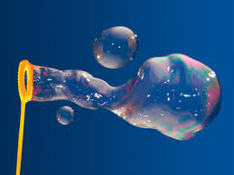

- Have a bottle of bubbles- obviously!
- Take the bubble wand out.
- Breath in deeply through your nose and hold for 3 seconds
- Exhale gently though your mouth, if this is done slowly it will produce lots of bubbles through he wand.
- Practice this until you are happy with your breathing, remember- nice and calm and slowly.
- Repeat the process at least 5 times- not only did you make bubbles which are cool at any age, but you have relaxed your body and mind.
- Do as many times in a day as you need.

