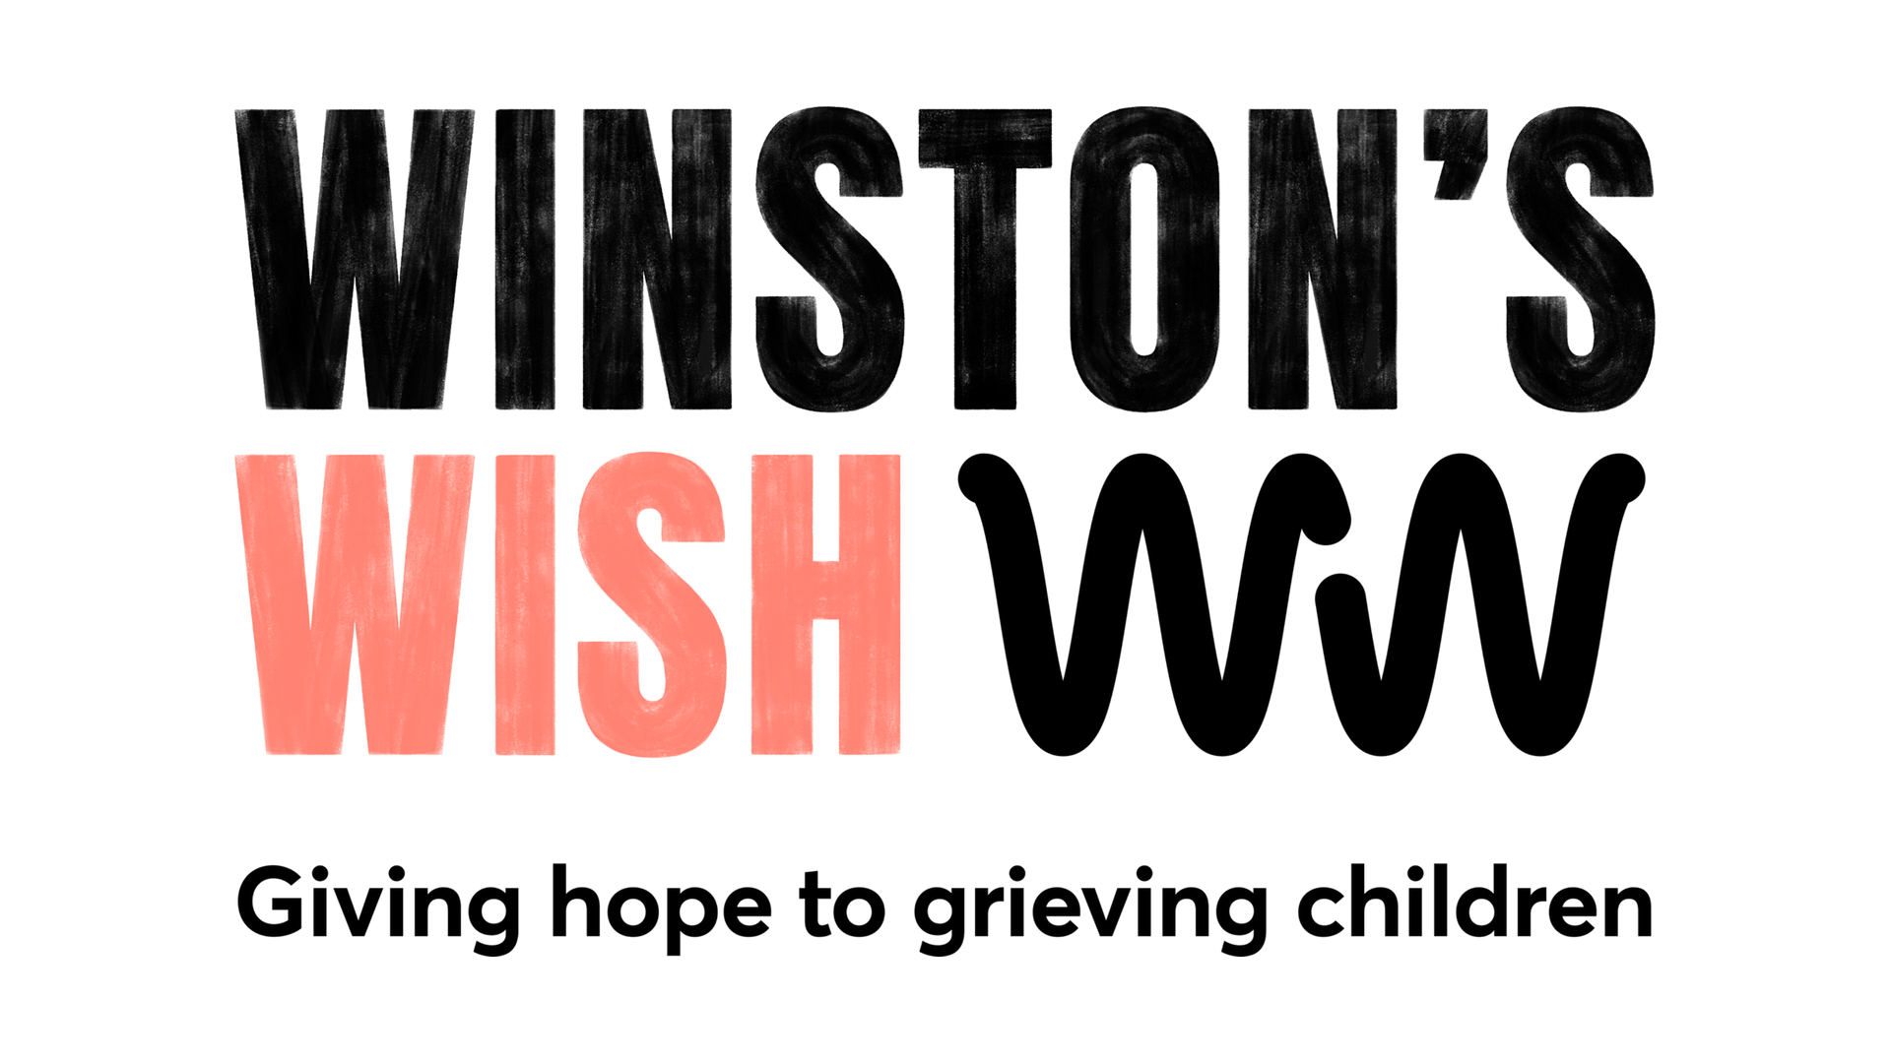

0

0

Ways to explain to a child that someone has died
Some suggested words:
“We know that all living things will die someday. Flowers, animals, trees, butterflies, people all die eventually…”
“… however, the great majority of people will die when they are very old.”
“Occasionally, someone will die before they are old because, for example, of an accident or serious illness.”
“When someone dies, their body stops working and they are no longer able to do the things they could when they were alive, such as move or talk or hug or play.”
“Sadly, [name] has died. Everyone wishes they had not died and had lived for many more years. However, their body was not able to keep working and so they died. Their heart stopped beating, their lungs stopped breathing and their brain stopped thinking, and so they died.”
“We are very healthy and we’re going to do all we can to keep that way, because I want to be around to [play with my great grandchildren/travel to Mars/celebrate the year 2100].”

Telling a child that someone important has coronavirus
Hopefully there will be time, even if only a short time, to prepare a child for the news that someone important has coronavirus. Here are some guiding words:
“I have something important to tell you. [Name] has become ill, and s/he has the illness called ‘coronavirus’. S/he is feeling ill, has a bad cough and feels hot. The illness means that s/he needs to stay in hospital. We won’t be able to visit them for at least a week. Perhaps you’d like to draw a picture/make a card/send a message to let her/him know you’re thinking about them. The doctors and nurses are all working really hard to get [name] better and we’re all hoping that s/he will be well again soon.”

Telling a child or young person that someone they know has died through coronavirus
“I have something very sad and difficult to tell you. [Name] died. You remember I told you that s/he had this illness called ‘coronavirus’ and that everyone was doing all they could to make them better? Sadly, despite all that [name] and the doctors and nurses did, the illness became too strong and their body could not get better. Their lungs stopped working and their heart stopped beating and they died.”

Talking to children about the death through coronavirus of other people/people they don’t know
Children and young people will also be aware of people outside their family and circle of friends who have the virus and there will be people they have heard of who might die. This is likely to make children wonder about the safety of those close to them. Acknowledging their anxiety is important, alongside realistic reassurance.
“It seems so shocking, doesn’t it, that [name of public figure] has died from the coronavirus? I know we didn’t know them, but it still feels very sad. I wanted to say that, here in this family, we are doing all the right things to avoid catching the virus. I know it can get dull sometimes but my job is to keep you safe and we’ll do all we can to keep us all well.”

