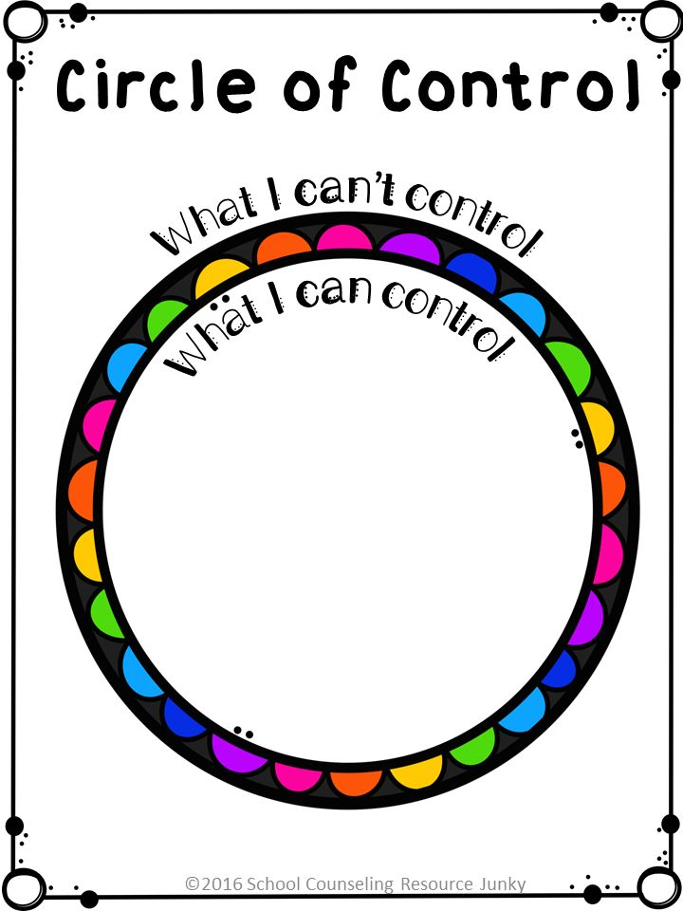
It’s ok to sometimes feel we are not in control or things are getting too confusing in our heads, we all have this feeling from time to time.
Use this sheet- inside the circle write down all the things you can control in your life- such as behaviour, work etc
Outside the circle write down all the things which worry you but you can’t control, such as behaviour of others, news, peoples social media etc.
Try to focus on the ones inside the circle. When you feel things are getting on top of you, focus your mind back to the inside circle.
Do this as many times as you need to, try to focus on this as you do some deep breathing to calm down the body if you feel you are getting panicky.

